Predicting the Trend of Stocks That are Listed at Two Different Exchanges

Bharat Premnath, Kentaro Osawa, Jeffrey Hu

DATS 6103.12 Introduction to Data Mining: Project Report

Dr. Tatiyana V Apanasovich

December 18, 2022

# 

# 

**Abstract** **4**

1. **Introduction** **5**

1.1 Broad view of the Stock Market 6

1.2 Our Work 7

1. **Exploratory Data Analysis** **8**

2.1 Infosys 8

2.1.1 Data Summary 8

2.1.2 Box Plots 9

2.1.3 Histograms 9

2.1.4 Correlation coefficients 11

2.1.5 Time Series Plots 12

2.2 Tata Motors 13

2.2.1 Data Summary 13

2.2.2 The correlation and covariance matrices 15

2.2.3 Box Plots 16

2.2.4 Histograms 17

2.3 ICICI Bank 21

2.3.1 Data Summary 21

2.3.2 Scatter Plots 21

2.3.3 Pair Plots 22

2.3.4 Histogram 23

1. **Models and Evaluations** **25**

3.1 Infosys 25

3.1.1 Building Models 25

3.1.2 Evaluating Models 31

3.1.3 Simulation using the best model 32

3.2 Tata Motors 34

3.2.1 Building Models 34

3.2.2 Simulation using the models 38

3.3 ICICI Bank 39

3.3.1 Model Summary 39

3.3.2 Simulation using the best model 43

1. **Future Research and Models** **44**

# 

# Abstract

In our study, we have devised a simple intraday trading strategy for stocks/equities of the same company listed in two different countries. From our Exploratory Data Analysis, we observed that companies who have stocks traded in two different countries, yet operate business in only one country, have a high correlation between the two countries’ stock prices, which also follow the same price trend. The trading strategy that we built for these stocks exploits the time difference between the two countries, in order to know the trend of the stock in one country and take a similar position in the other country. We employed machine learning models by utilizing the price and volume information of the stock at one exchange to predict the trend at the other exchange. Using our models, we ran simulations to calculate cumulative returns for each stock as well. The results showed that our models produced returns equal to or better than the 1:1 signal strategy trading, which assumes that the stock trend (either positive or negative) in one market always follows the other market’s stock trend.

# Introduction

## 1.1 Broad view of the Stock Market

### Nature of the Stock Market

The World Stock Markets are exchanges where uncertainty and volatility are inherent, and a day of great returns is no indication of how it will perform tomorrow. The capricious nature of stock prices makes the stock market look like it prints money when the prices rally, and burns money when the prices plummet. These euphoria and fear-driven perceptions lead stock market participants to make decisions based on emotions, and because of this, many stock traders are punished for their irrational decisions and suffer monetary losses. In order to effectively participate in these volatile markets, one must account for these risks and understand their purpose and objectives when trading in the market. When the objective and risk tolerance level is defined, it helps clarify the role that the participants have within the context of the stock market.

### Participants of the Stock Market

Broadly speaking, there are three types of participants in the stock market. An individual may play different roles in different market conditions. Their participation is based on their motives, objectives, and risk tolerance levels.

1. **Investors** – Participants who assume this role prioritize building on their initial capital or investment over a longer timeframe than other participants. They focus on the growth prospects of the company/asset that they’ve invested in, and often wait for a relatively longer period of time until the stock price appreciates massively. Investors do not focus on daily fluctuations of their chosen stocks. Instead, they focus on the long-term trends, like yearly quarters. For example, investors can just ignore the daily short-term noises, or hedge (taking a counter position to offset losses on investments) their investments depending on their risk management.
2. **Traders** – Traders don’t focus on the long-term growth aspects of the stock. Instead, they stay in the market for a relatively short period of time, compared to investors. Traders primarily focus on earning from the daily or weekly fluctuations of a stock price by trading on the fall/rise of the stock price. The trader’s strategy revolves around the principle of “High-Risk, High-Reward”. These participants and strategies are what we will be focusing on in this report.
3. **Arbitrageurs** – Arbitrageurs are participants who, ideally, aim to make risk free profits by engaging in arbitrage. This involves buying and selling an asset/stock simultaneously at two different markets for two different prices. For example, an arbitrageur would buy an apple at 2$ and sell it for 4$ at a different market.

### The Nature of Trading

There are many reasons as to trade in the stock market despite the risk it carries. For example:

1. Trading can be done even with minimal capital.
2. The profit on capital employed can be very large depending on the risk and market fluctuations, even 100% of the initial investment in a single day.
3. This business can be run at any location in the world.

Trading without a tested strategy can often be disastrous, and depending on the risk, can be equivalent to gambling without a safety net. Oftentimes, traders utilize different strategies for different market segments and depending on the conditions. Trading is not easy, and requires skills such as market knowledge, dynamic thinking, risk management, up-to-date information, and a healthy emotional and mental balance. However, with the advent of algorithmic trading, it has eliminated some of the personal emotion in the trading, which adds both advantages and disadvantages. One advantage is the elimination of human involvement and fast execution of orders when trading, and a disadvantage is that the human instinct gained from experience can sometimes outperform algorithmic trading. Of course, nowadays, some algorithms and traders are taking advantage of human emotions by tracking market sentiment, and using models that take market sentiment into account.

## 1.2 Our Work

We focused on a few particular stocks that are listed on both the New York Stock Exchange (NYSE) and the National Stock Exchange India (NSE), in order to predict the stock direction in one market from the data in the other. For this study, we turned to American Depositary Receipts (ADRs), which are traded at the NYSE and offer US investors a means to gain investment exposure to non-US stocks without the complexities that come in dealing with foreign stock markets. ADRs and NSE stocks are traded at different times. This time difference can be exploited to know the stock's price trend in advance, at either of the exchanges. We obtained our stock data from Yahoo! finance ([https://finance.yahoo.com/](https://finance.yahoo.com/chart/INFY.NS#-)) for three Indian companies with ADRs: Infosys, Tata Motors, and ICICI Bank. We used classification models such as Logistic Regression, Random Forests, and Gradient Boosted Trees to predict the stock trend at NSE from NYSE data for Infosys, and the trend at NYSE from NSE data for Tata Motors and ICICI Bank.

# 

# 

# 

# 2. Exploratory Data Analysis

## 2.1 Infosys

### 2.1.1 Data Summary

We attempted to predict whether the difference between the close and open prices at NSE would be positive or negative by using the previous business day's data at NYSE. Therefore, we created the data frame shown below from the original data. This new data frame had ten columns and 3084 rows.

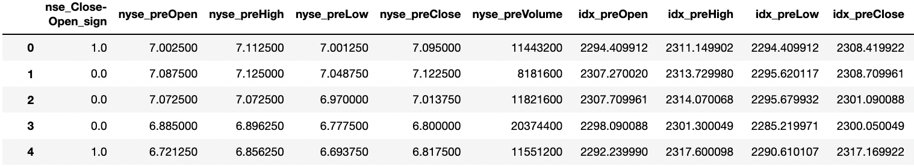

***Figure 2.1.1***: The first five rows of the data frame for Infosys

The definition of each column in the data frame is as follows.

* **nse_Close-Open_sign**: The sign of the difference between the close price and the open price at NSE. If close price - open price > 0, nse_Close-Open_sign takes "1.0." Otherwise, nse_Close-Open is "0.0." This variable is the response variable of our models for Infosys.
* **nyse_preOpen**: The previous business day’s open price of Infosys ADR.
* **nyse_preHigh**: The previous business day’s high price of Infosys ADR.
* **nyse_preLow**: The previous business day’s low price of Infosys ADR.
* **nyse_preClose**: The previous business day’s close price of Infosys ADR.
* **nyse_preVolume**: The previous business day’s volume of Infosys ADR.
* **idx_preOpen**: The previous business day’s open price of Nasdaq.
* **idx_preHigh**: The previous business day’s high price of Nasdaq.
* **idx_preLow**: The previous business day’s low price of Nasdaq.
* **idx_preClose**: The previous business day’s close price of Nasdaq.

### 2.1.2 Box Plots

We created box plots for all nine independent variables. The x-axis is the response, and the y-axis is each variable. There is no apparent difference between nse_Close-Open_sign = 0 and nse_Close-Open_sign = 1.

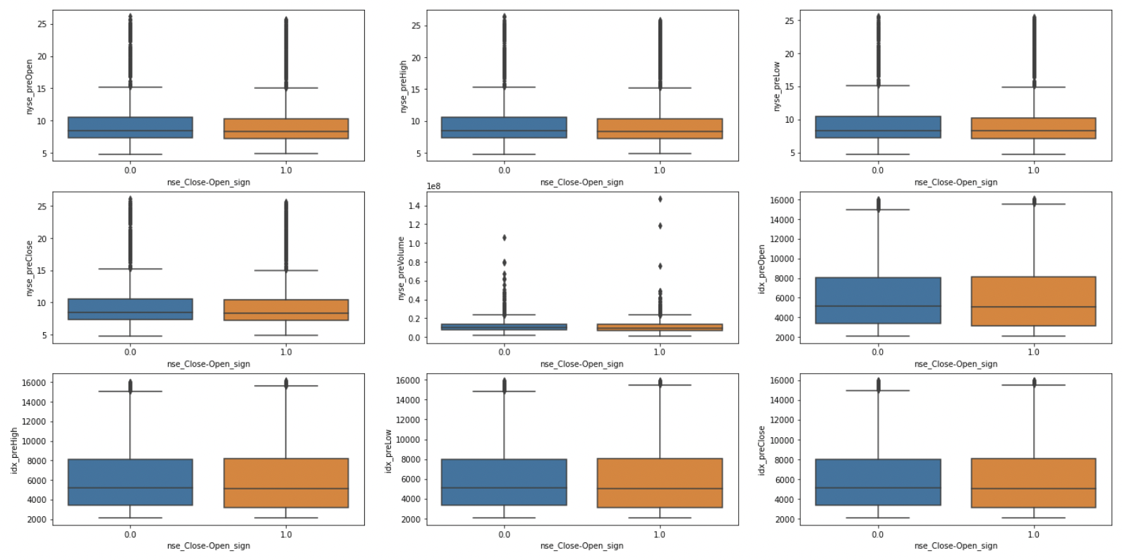

***Figure 2.1.2*** : Box plots of each independent variable

### 2.1.3 Histograms

The histograms of each variable are shown below. The value of nse_Close-Open_sign colors the bars. There is no apparent difference between the distributions of nse_Close-Open_sign = 0 and 1.

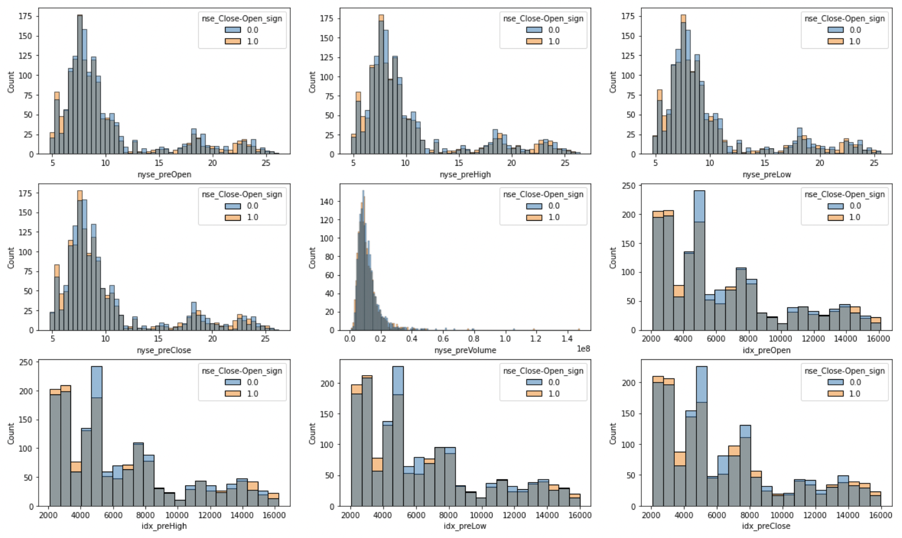

***Figure 2.1.3*** : Histograms of each independent variable

We created another histogram to check the relationship between the previous business day’s difference of the close price and the open price of Infosys ADR and nse_Close-Open_sign. The x-axis of the figure below is as follows.

$\frac{nyse_preClose - nyse_preOlose}{nyse_preOpen}×100$

The value of the response variable colors the bars. Although the distributions of nse_Close-Open_sign = 0 and 1 are slightly off, they are almost the same.

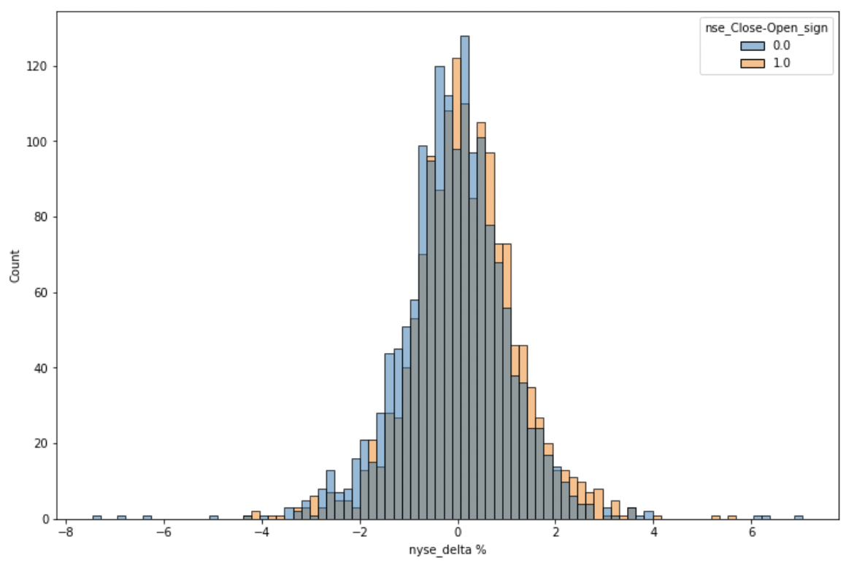

***Figure 2.1.2 b***: Histograms of the difference between the close price and the open price at NYSE

### 2.1.4 Correlation coefficients

The heat map below shows the correlation between independent variables. The correlation coefficients within the Nasdaq variables are one, as are those within the Infosys ADR variables. It can be seen that the Infosys ADR variables and the Nasdaq variables are strongly correlated.

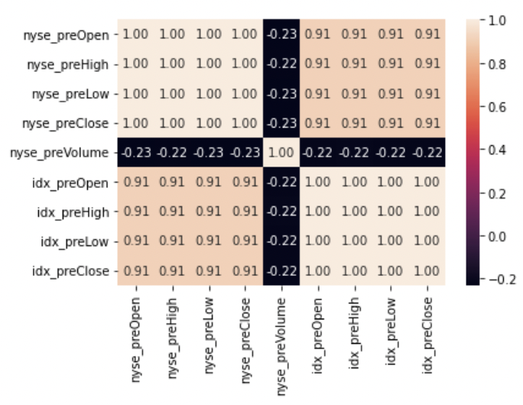

***Figure 2.1.4*** : Correlation coefficient heat map of independent variables

### 2.1.5 Time Series Plots

The figure below shows the relationship between the open price and the number of days in 2010. The left side shows the time-series change in the opening price of Infosys at NSE, while the right side shows the time-series change in the opening price of Infosys at NYSE; it can be seen that the trends of NSE and NYSE are very similar. Only the data for 2010 is shown, as the same is true for other years.

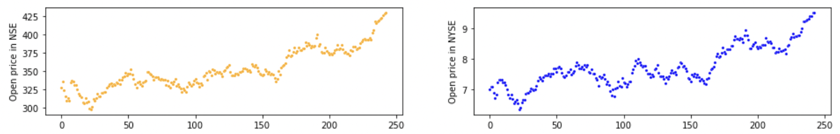

***Figure 2.1.5*** : Time series changes of the open price at NSE and NYSE in 2010

## 2.2 Tata Motors

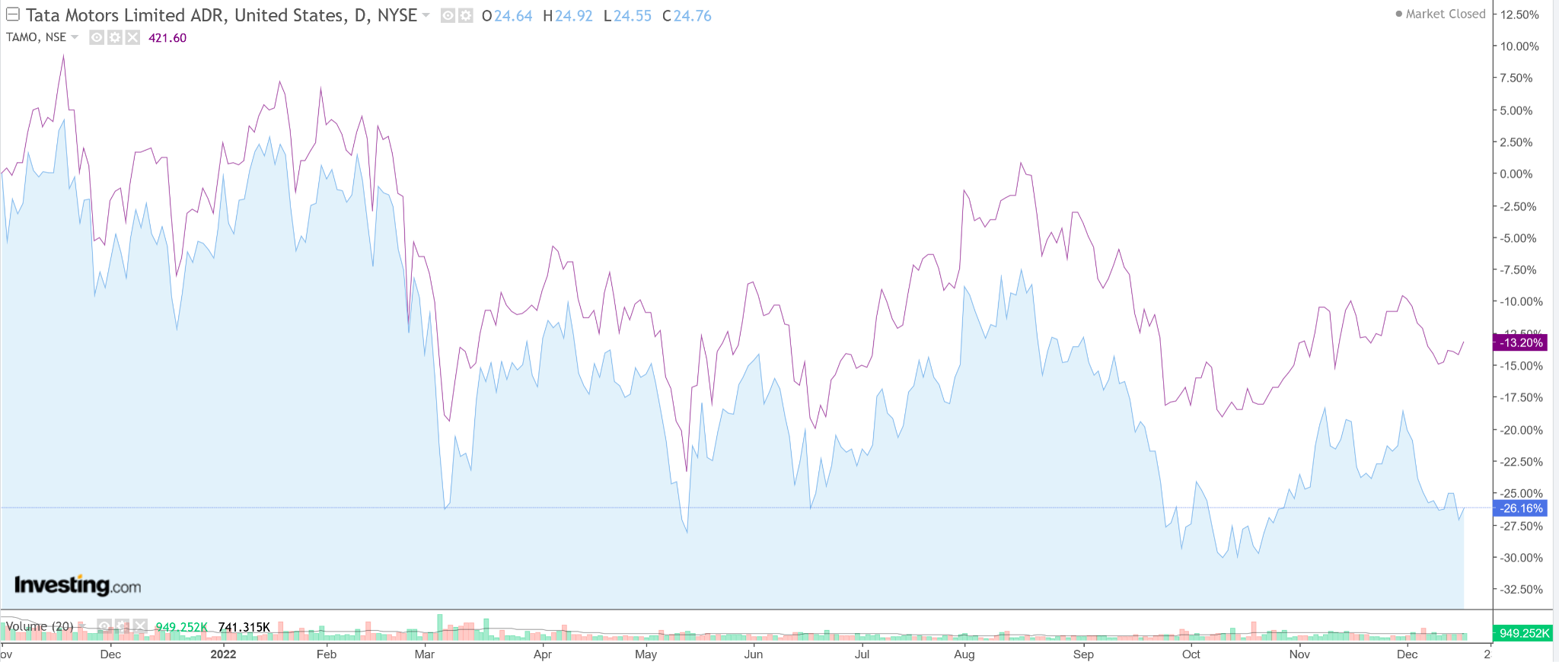

***Figure 2.2***: The time series plot of Tata Motors ADR (Blue area) and Tata Motors NSE (purple line).

### 

### 

### 

### 2.2.1 Data Summary

Hinted by the above price chart of the Tata Motors stock pairs, the 10 year (2012-2022) price (Open,Close,High,Low) and Volume data were scraped from Yahoo Finance. Also, the NSE and NYSE index data were scraped to check the dependency of the prices on the indices. For this case, only the business days on which both the NSE and NYSE were open were considered. All the data was consolidated in a pandas dataframe.

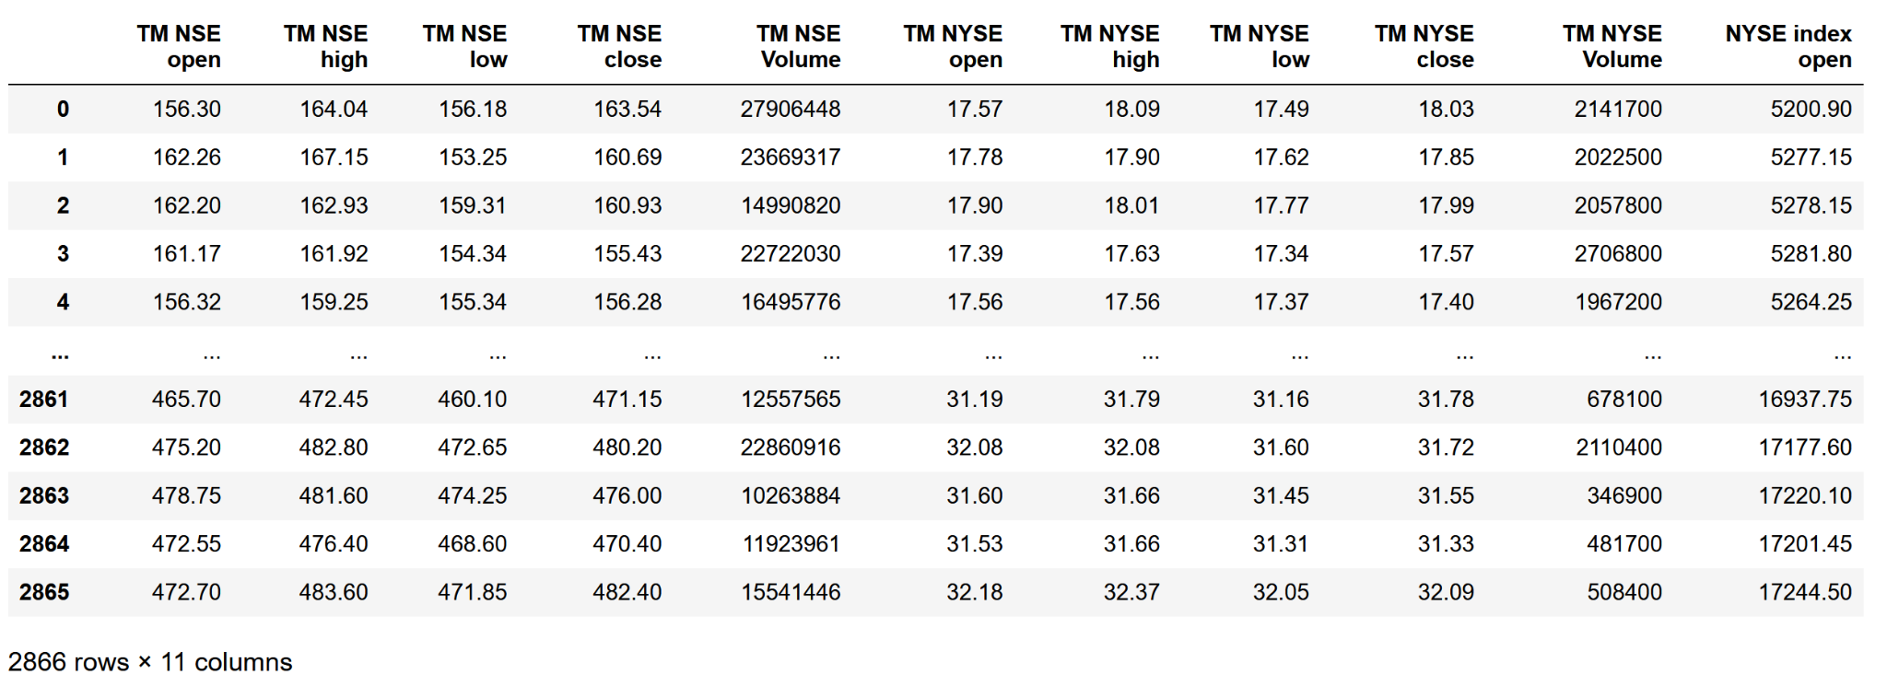

***Figure 2.2.1*** : The dataset of Tata Motors stock prices and index values of NSE and NYSE

The data frame consisted of 2866 entries of the following data attributes:

* **TM NSE open** - The Open price of the Tata Motors stock at NSE
* **TM NSE high** - The High price of the Tata Motors stock at NSE
* **TM NSE low** - The Low price of the Tata Motors stock at NSE
* **TM NSE close** - The close price of the Tata Motors stock at NSE
* **TM NSE Volume** - The number of Tata Motors shares traded at NSE
* **TM NYSE open** - The Open price of the Tata Motors stock at NYSE
* **TM NYSE high** - The High price of the Tata Motors stock at NYSE
* **TM NYSE low** - The Low price of the Tata Motors stock at NYSE
* **TM NYSE close** - The close price of the Tata Motors stock at NYSE
* **TM NYSE Volume** - The number of Tata Motors shares traded at NYSE
* **NYSE index open** - The NYSE composite index value at the open of the NYSE
* **NYSE index high** - The highest value NYSE composite index reached on a day
* **NYSE index low** - The lowest value the NYSE composite index reached on a day
* **NSE index close** - The value at which the NSE index closed
* **NSE index open** - The NSE index value at the open of the NSE
* **NSE index high** - The highest value NSE index reached on a day
* **NSE index low** - The lowest value the NSE index reached on a day
* **NSE index close** - The value at which the NSE index closed

### 2.2.2 The correlation and covariance matrices

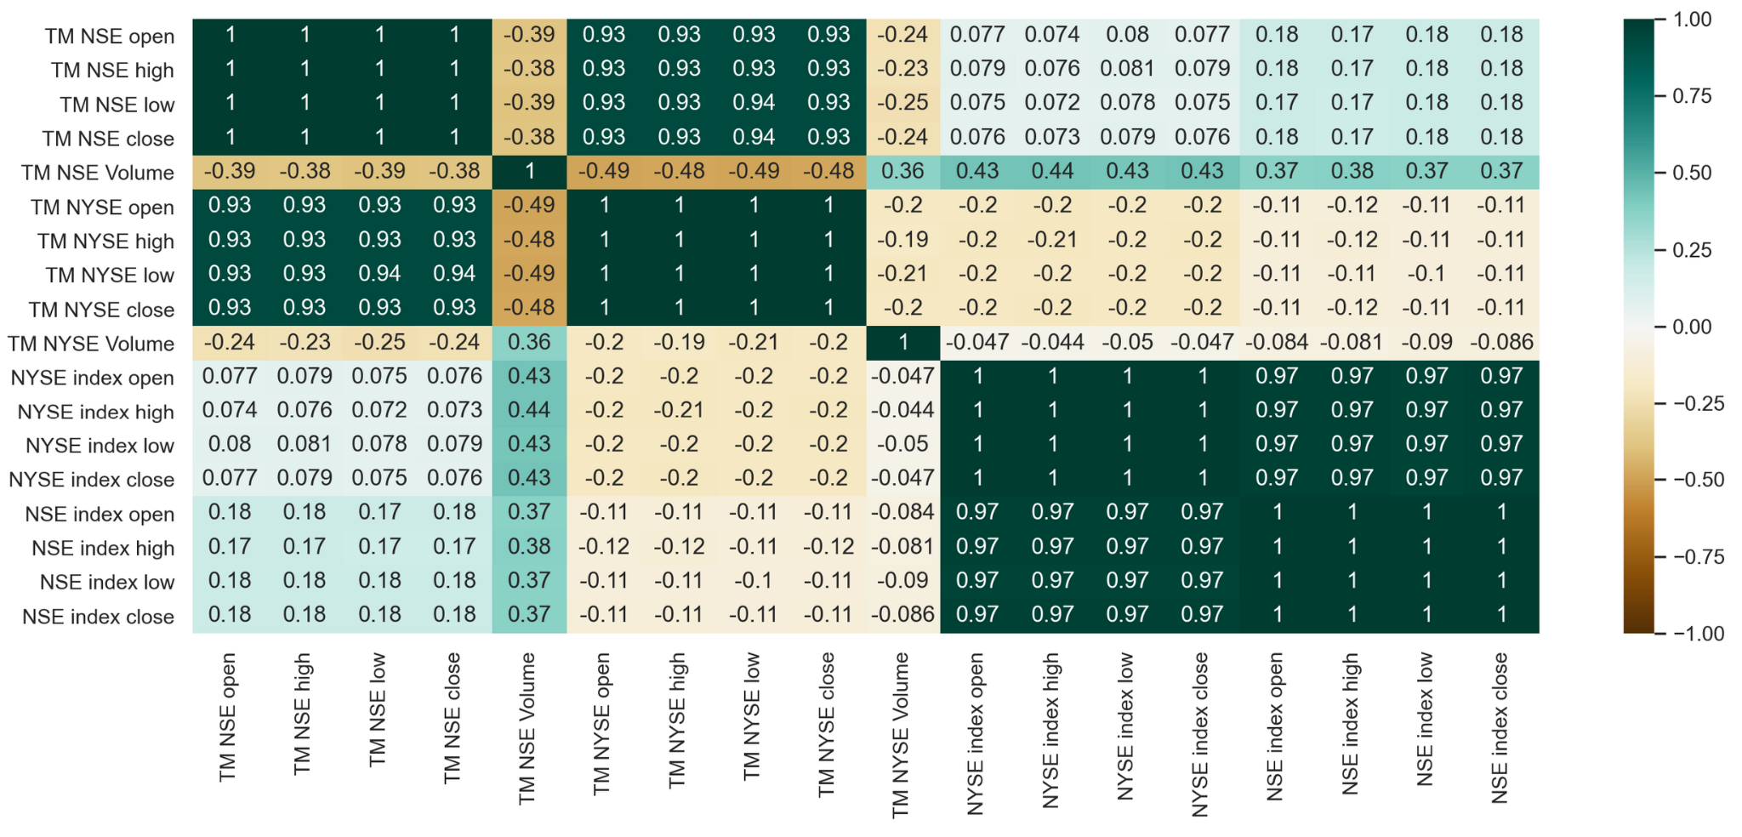

***Figure 2.2.2*** : The heatmap correlation matrix of the attributes of the Tata Motors dataset

It can be seen that the price correlation between the stock pairs is very huge, around 93% for all open, close, high and low prices. Also, it was observed that the correlation between the NYSE index and Tata Motors ADR was around -20% and the correlation between the Tata Motors at NSE and the NSE index was around 18%. It can be seen that only prices have very high correlation between themselves and the effect of indices are not very significant. However, the NSE and NYSE indices have a very high correlation of 97%.

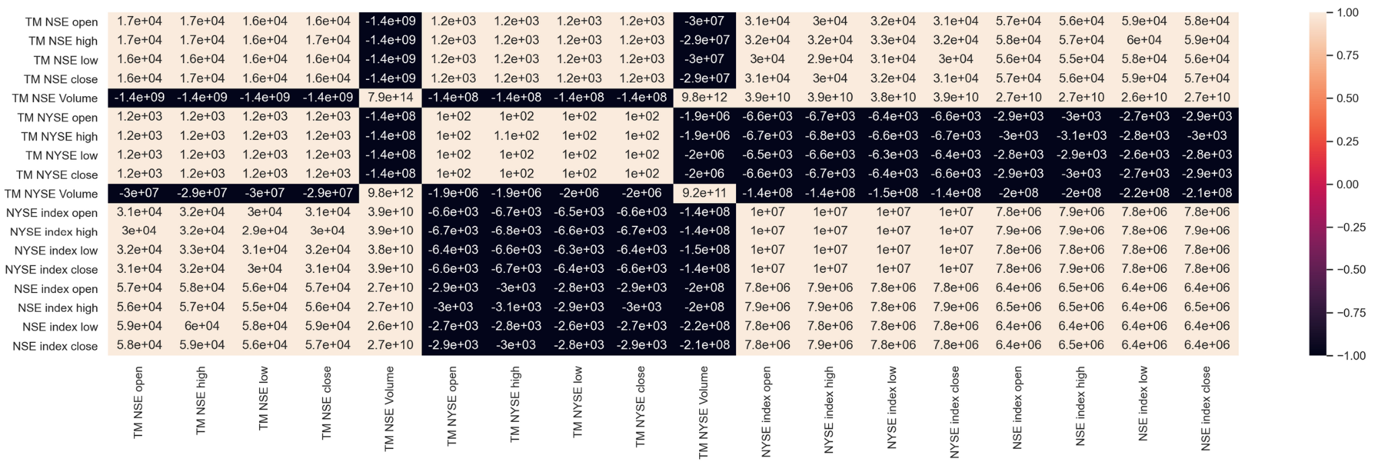

***Figure 2.2.2 b*** : The covariance matrix of attributes of the Tata Motors dataset

### 2.2.3 Box Plots

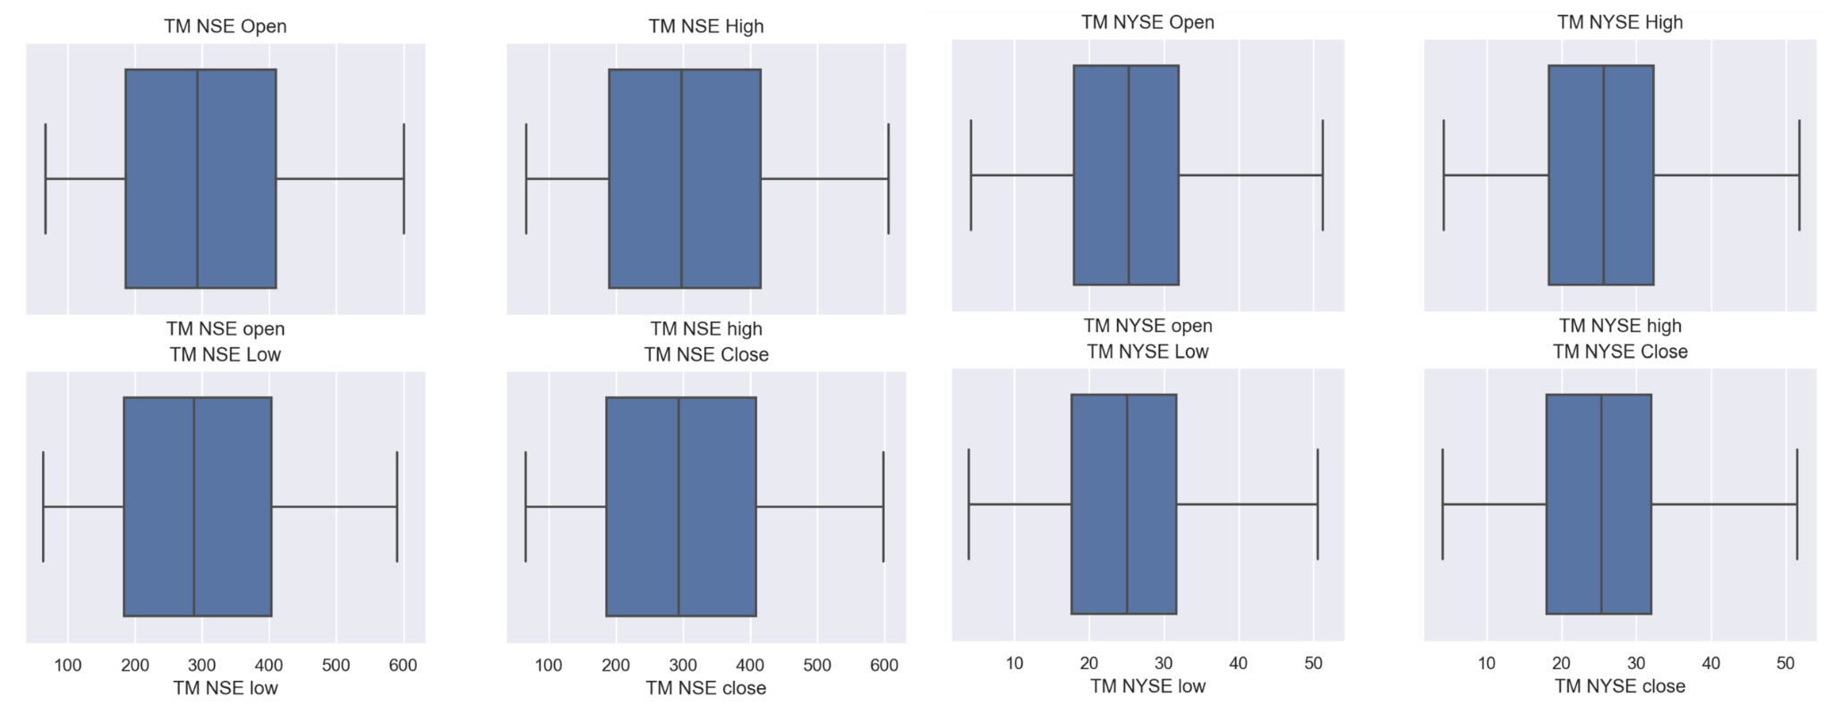

***Figure 2.2.3*** : Box plots of Open, Close, High and Low prices of both ADR and NSE stock

### 2.2.4 Histograms

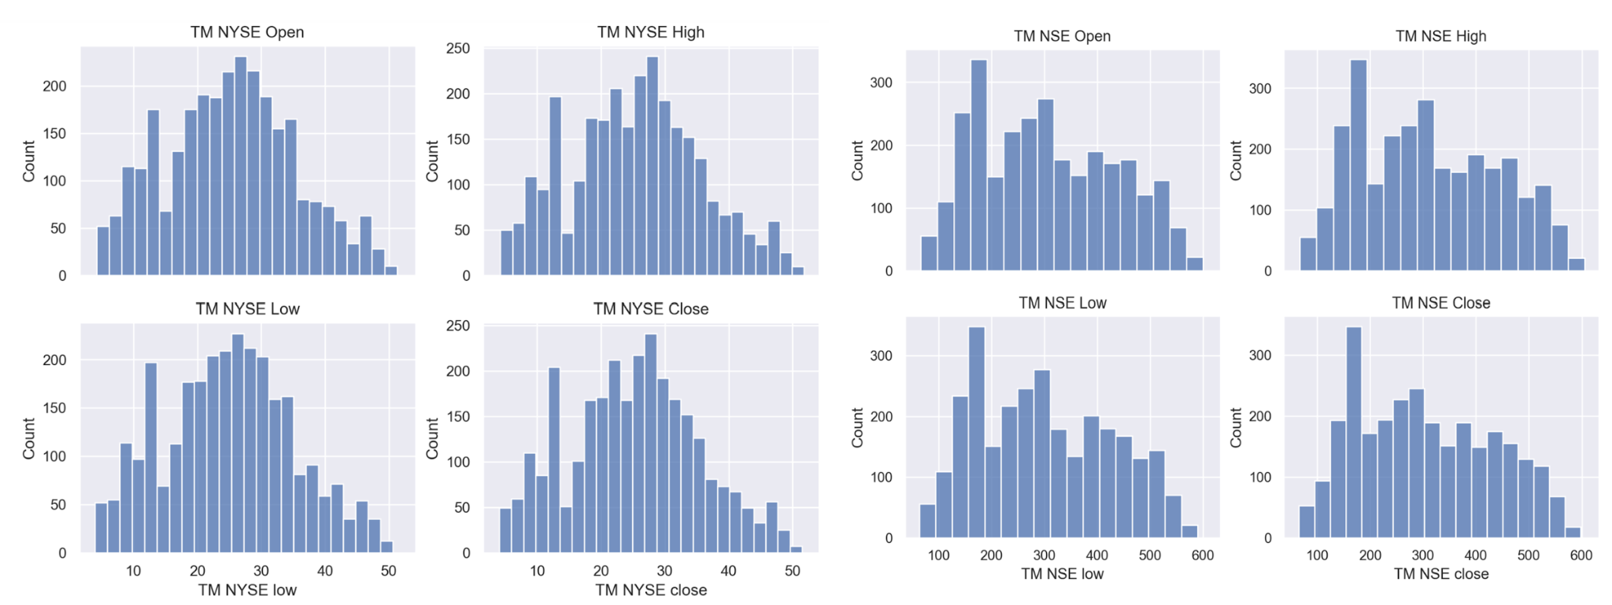

***Figure 2.2.4*** : The price histograms of Tata Motors ADR and Tata Motors stocks

The histograms depict the fact that the prices of ADR and NSE stocks have been range bound from 2012-2022.

Another histogram was created to see the relationship between the % change in the stock price and for that particular % change in the stock price, how many times the trend followed and how many times the trend didn’t follow.

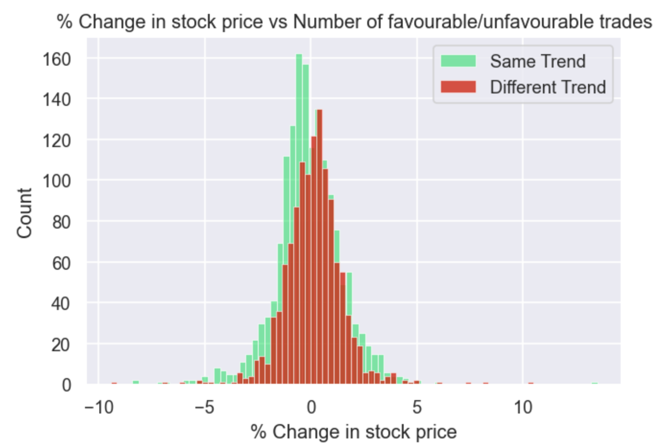

***Figure 2.2.4 b*** : The histogram of % change in the stock price and count

% Change = $\frac{ADR_close - ADR_open}{ADR_open}×100$

The above is the formula for % change of ADR stock price used for the x-axis in the histogram. This histogram gives an important insight about the strategy, the red bars in the histogram show the losses and the green bars show the profits. It is clear that in a span of 10 years the number of times profits were made is more than the number of times the losses incurred. Also, it can be noticed that the majority of the profits were made when the stock price went down compared to when it went up. One more important observation from the histogram is whenever the stock has made a large price move there is a high probability that the trend will be followed by the ADR . In other words, when there is high volatility the probability of trend following is more.

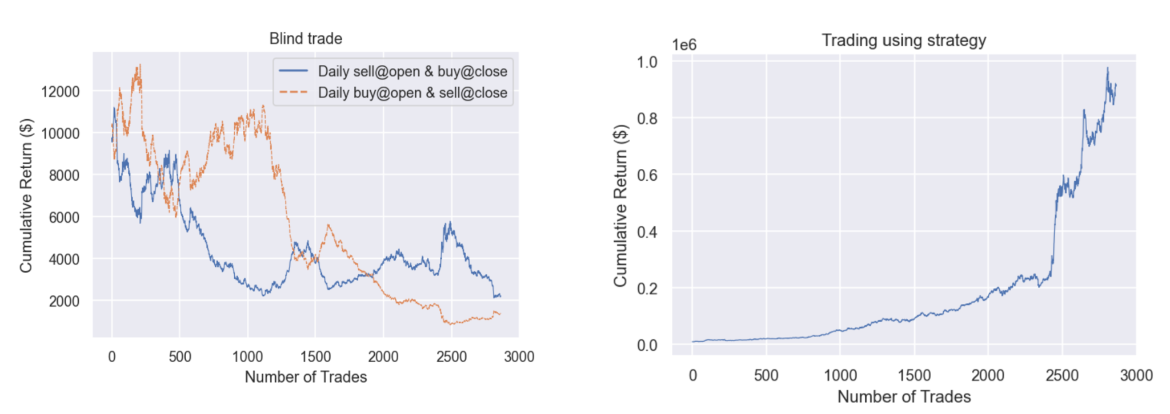

***Figure 2.2.4 c*** : A comparison of the returns from Strategy trading and Blind trading.

For backtesting the strategy, an initial capital of 10,000 usd was considered and the capital grew at the rate of 45.36 % CAGR leading to a sum of 913,334.68 $ (8804.5% Return on Investment). A tax and brokerage fee of 0.05% of the entire capital was considered for every trade. However, the effect of slippage was not considered.

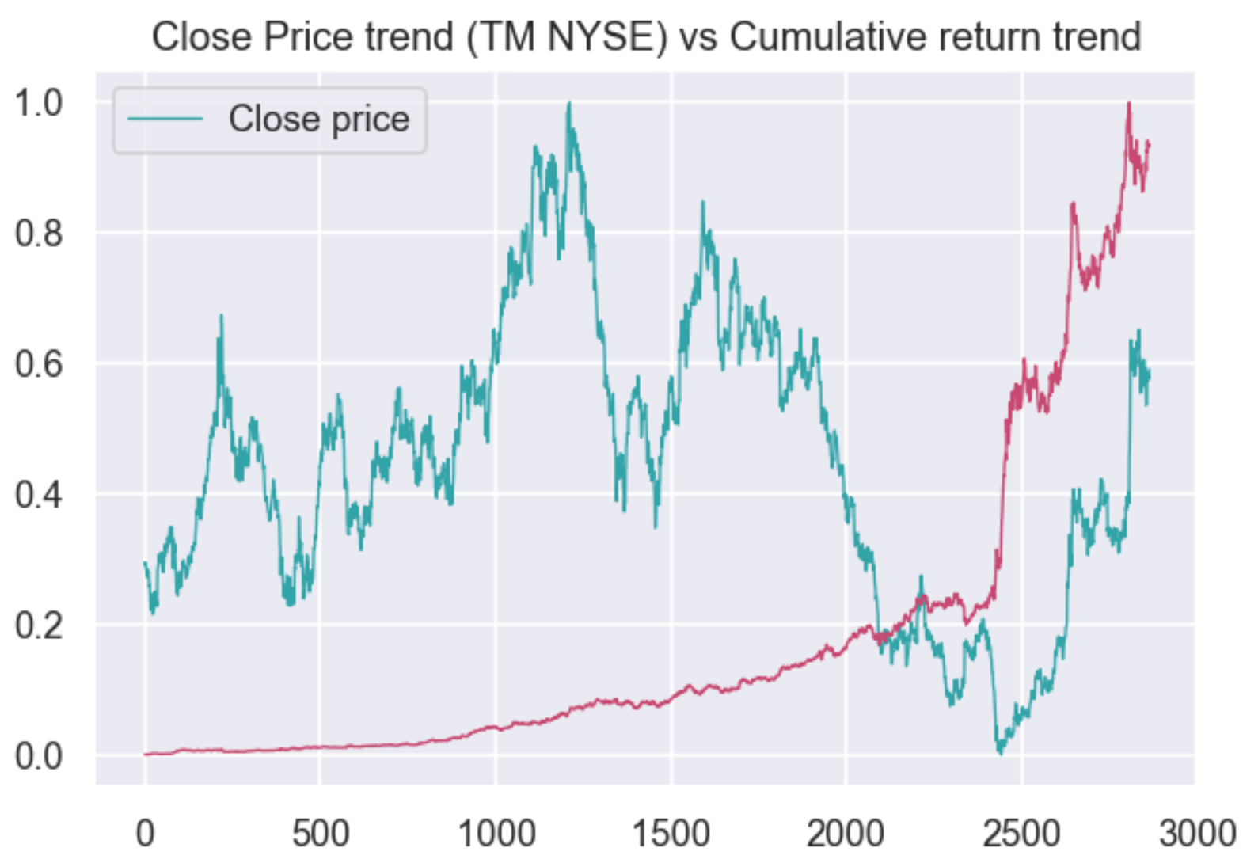

***Figure 2.2.4 d*** : A comparison of the closing price trend (scaled between 0 and 1) and the cumulative returns trend (scaled between 0 and 1) .

It can be seen from the plot that, before the 2500th trade there is a huge jump in the profits and the reason being that it was Covid-19 crisis and the stock price continued to fall at NSE and this opportunity was very well exploited by the strategy by being right about the fall at NYSE and almost tripled the investment. In a way it can be said that volatility is a boon for this strategy.

## 

## 

## 2.3 ICICI Bank

### 2.3.1 Data Summary

The original nine features used to predict the New York Stock Exchange (NYSE) were the Open, Close, High, and Low from both the index (NIFTY) for the Indian Stock Exchange (NSE), and the listed price for ICICI Bank stock on the NSE. For these particular models, we decided to also add the High/Low difference for the ICICI Bank on NSE, and the NSE Percent Change, which is the difference of the close and open price of ICICI Bank as a percentage of the open price on the NSE. The NSE Percent Change feature will be illustrated in greater detail in the histogram later. The dataset has 2969 rows, or observations, over an 11 year period (not including days when either of the exchanges were not trading), starting from January 4th, 2010, and ending on December 31st, 2021.

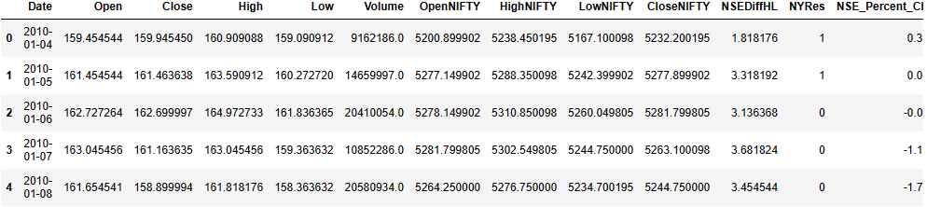***Figure 2.3.1*** : The dataset of ICICI Bank and NSE index values

### 2.3.2 Scatter Plots

From the correlation plots, the relationship between the NYSE and NSE is clear to see. Both the Open and Close prices between the two exchanges have a very strong linear positive relationship with each other. The Open and Close prices of ICICI Bank on the NSE are on the y-axis, and the Open and Close prices on the NYSE are on the x-axis.

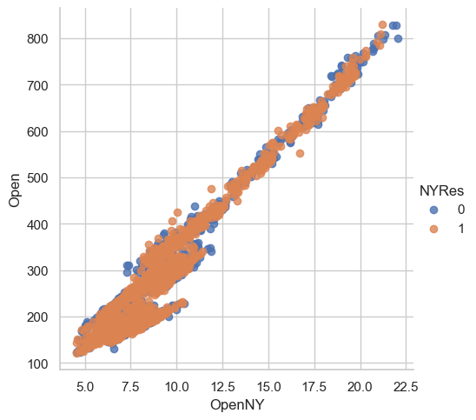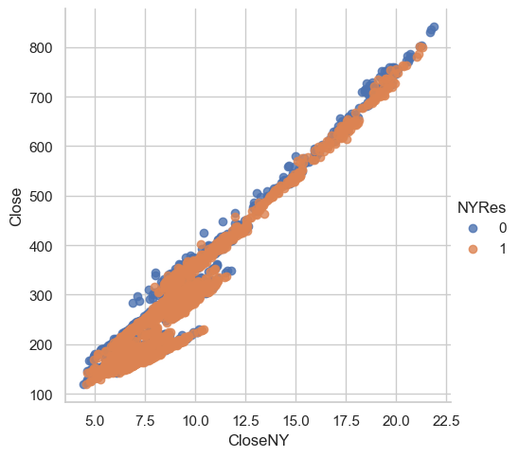

***Figure 2.3.2*** : Scatter plots between the NSE and NYSE Open and Close Prices for ICICI Bank

### 2.3.3 Pair Plots

Here are pair plots between the NSE indicators (High, Low, Open, Close), as well as the NSE Percent Change, all colored by the NYSE signal. While the indicators all have an extremely strong linear correlation with each other, it’s much harder to visualize the relationship between the indicators and the NYRes signals in just the pair plots. The indicators, excluding volume, seem to share the same trend, with a right-tailed distribution.

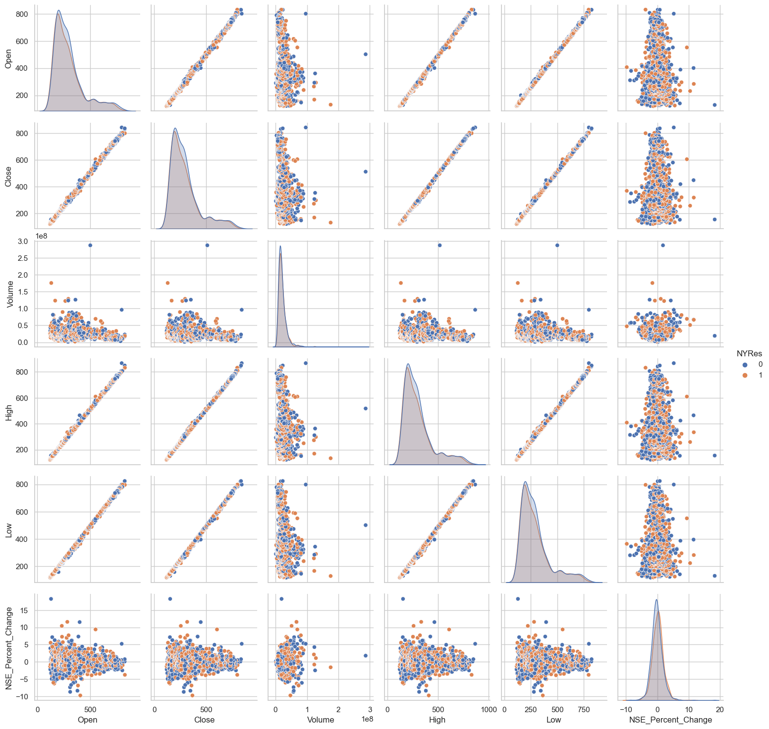

***Figure 2.3.3*** : Pairplot for the ICICI Bank stock on NSE, colored by the NYSE signal

### 2.3.4 Histogram

Much like the pair plots above, there is a lot of visible overlap in the signals. However, it can still be seen that a small majority of those above 0 percent change in the NSE are also signal 1 on the NYSE, and vice versa. This is represented by the blue rectangles above the gray, for NSE Percent Change =< 0, and the orange rectangles above the gray, for NSE Percent Change > 0. This slight disparity is what the strategy hopes to employ and exploit, and what the models hope to capitalize on.

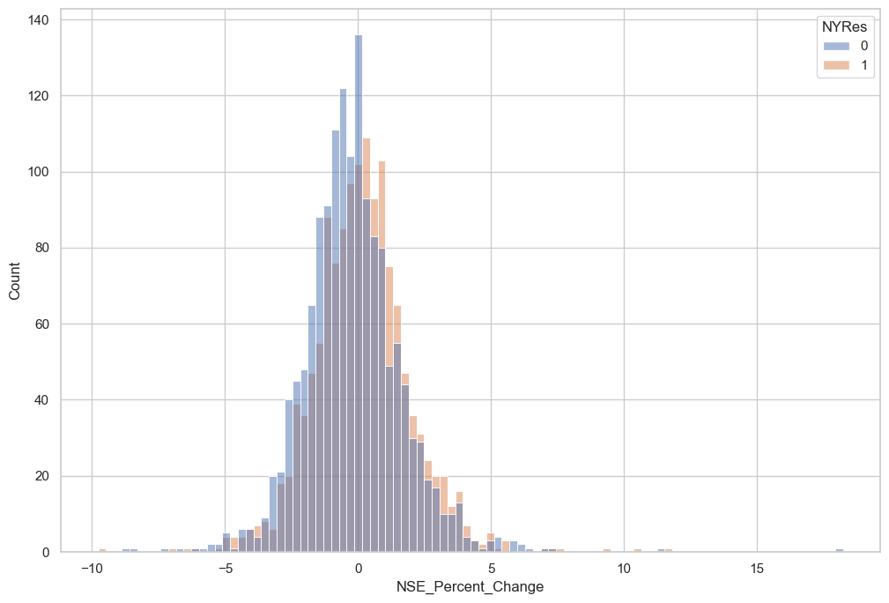

***Figure 2.3.4*** : Percent Change Histogram, by the NYSE signal

# 

# 3. Models and Evaluations

## 3.1 Infosys

Although it was clear from the EDA that the trends in the NSE and NYSE were very similar, no explanatory variables highly correlated with the response variable. Therefore, we first created some models using all the explanatory variables. Then, we also built models with some features dropped. The best model was selected from these models in terms of accuracy and AUC values.

### 3.1.1 Building Models

The data were divided into the training data (70% of the total) and the testing data (30% of the total) with random_state = 1000.

**Logistic regression model with all variables.** The table below shows the model’s intercept and coefficients.

***Table 3.1.1*** : Intercept and coefficients of the logistic regression model with all variables

| Variable | Coefficient |
| --- | --- |
| Intercept | -0.03783184 |
| nyse_preOpen | -6.98981214 |
| nyse_preHigh | -2.42919587 |
| nyse_preLow | 0.86074968 |
| nyse_preClose | 8.50755189 |
| nyse_preVolume | -0.02079577 |
| idx_preOpen | 8.56267991 |
| idx_preHigh | -5.69555529 |
| idx_preLow | -1.98276139 |
| idx_preClose | -0.83338066 |

The figure below shows the confusion matrix calculated using the testing data and the ROC curve, respectively. The accuracy was 0.539, and AUC was 0.537.

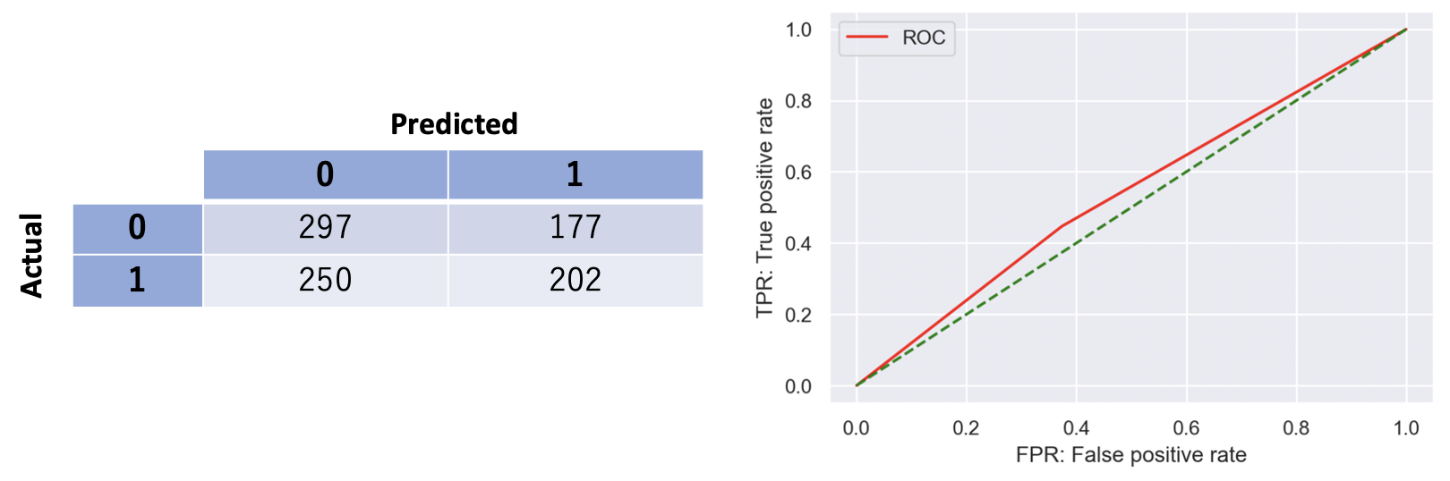

***Figure 3.1.1*** : The confusion matrix and ROC curve from the logistic regression model with all variables

**Random forest with all variables.** The table below shows the hyperparameters tuned by GridSearchCV.

***Table 3.1.2*** : Hyperparameters selected by GridSearchCV

| Hyperparameter | Value |
| --- | --- |
| n_estimaters | 200 |
| max_depth | 3 |
| max_features | None |
| bootstrap | True |

The figure below shows the confusion matrix calculated using the testing data and the ROC curve, respectively. The accuracy and AUC were 0.524 and 0.518, respectively.

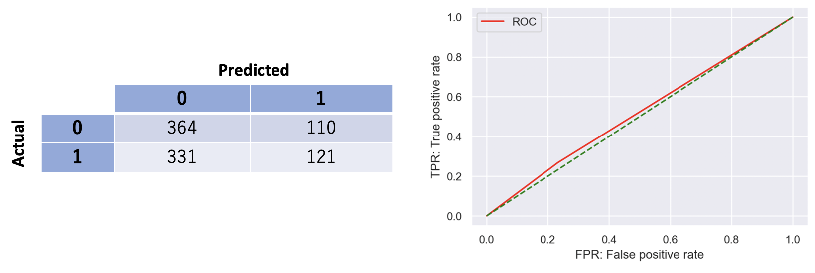

***Figure 3.1.2*** : The confusion matrix and ROC curve from the random forest with all variables

**Boosting with all variables.** The table below shows the hyperparameters tuned by GridSearchCV.

***Table 3.1.3*** : Hyperparameters selected by GridSearchCV

| Hyperparameter | Value |
| --- | --- |
| n_estimaters | 100 |
| max_depth | 2 |
| learning_rate | 0.1 |
| max_features | ‘sqrt’ |

The figure below shows the confusion matrix calculated using the testing data and the ROC curve, respectively. The accuracy and AUC were 0.493 and 0.489, respectively.

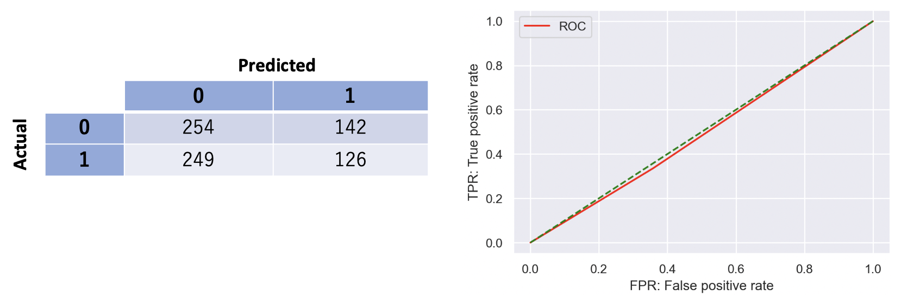

***Figure 3.1.3*** : The confusion matrix and ROC curve from the boosting with all variables

**Logistic regression model with three variables.** We selected the features to be introduced into the new models based on the feature importance of the random forest and the boosting. The table below shows the feature importance from the random forest model and the boosting model.

***Table 3.1.4*** : Feature importance from the random forest and the boosting

| Variable | Random forest | Boosting |
| --- | --- | --- |
| nyse_preOpen | 0.151604 | 0.139658 |
| nyse_preHigh | 0.095225 | 0.090101 |
| nyse_preLow | 0.056832 | 0.081550 |
| nyse_preClose | 0.093616 | 0.131612 |
| nyse_Volume | 0.220314 | 0.214686 |
| idx_preOpen | 0.073584 | 0.061854 |
| idx_preHigh | 0.095287 | 0.090572 |
| idx_preLow | 0.090984 | 0.108757 |
| idx_preClose | 0.122555 | 0.081210 |

We chose to use nyse_preOpen, nyse_preClose, and nyse_preVolume because they have relatively high importance.

The table below shows the intercept and coefficients of the feature-reduced logistic regression model.

***Table 3.1.5*** : Intercept and coefficients of the logistic regression model with three variables

| Variable | Coefficient |
| --- | --- |
| Intercept | -0.03732964 |
| nyse_preOpen | -5.3793651 |
| nyse_preClose | 5.36950525 |
| nyse_preVolume | -0.03751534 |

The figure below shows the confusion matrix calculated using the testing data and the ROC curve, respectively. The accuracy was 0.542, and AUC was 0.539.

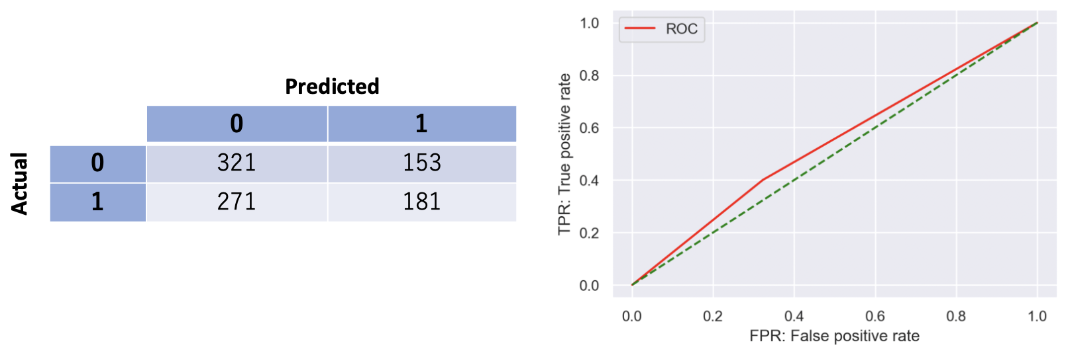

***Figure 3.1.4***: The confusion matrix and ROC curve from the logistic regression model with three variables

**Random forest with three variables.** The table below shows the hyperparameters tuned by GridSearchCV.

***Table 3.1.6*** : Hyperparameters selected by GridSearchCV

| Hyperparameter | Value |
| --- | --- |
| n_estimaters | 100 |
| max_depth | 5 |
| max_features | ‘sqrt’ |
| bootstrap | True |

The figure below shows the confusion matrix calculated using the testing data and the ROC curve, respectively. The accuracy and AUC were 0.510 and 0.504, respectively.

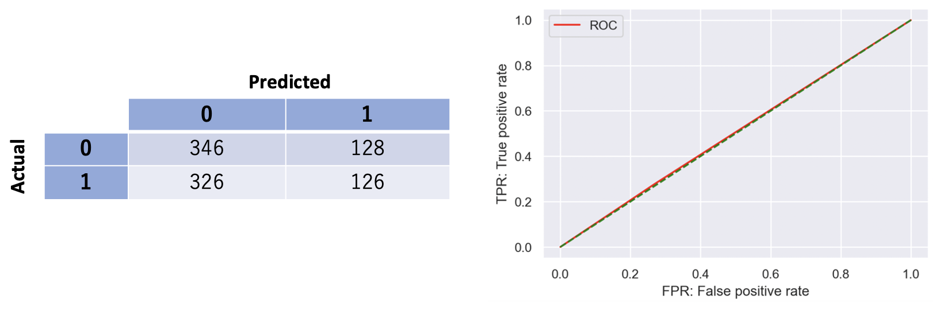

***Figure 3.1.5*** : The confusion matrix and ROC curve from the random forest with all variables

**Boosting with three variables.** The table below shows the hyperparameters tuned by GridSearchCV.

***Table 3.1.7*** : Hyperparameters selected by GridSearchCV

| Hyperparameter | Value |
| --- | --- |
| n_estimaters | 700 |
| max_depth | 2 |
| learning_rate | 0.1 |
| max_features | ‘sqrt’ |

The figure below shows the confusion matrix calculated using the testing data and the ROC curve, respectively. The accuracy and AUC were 0.514 and 0.513, respectively.

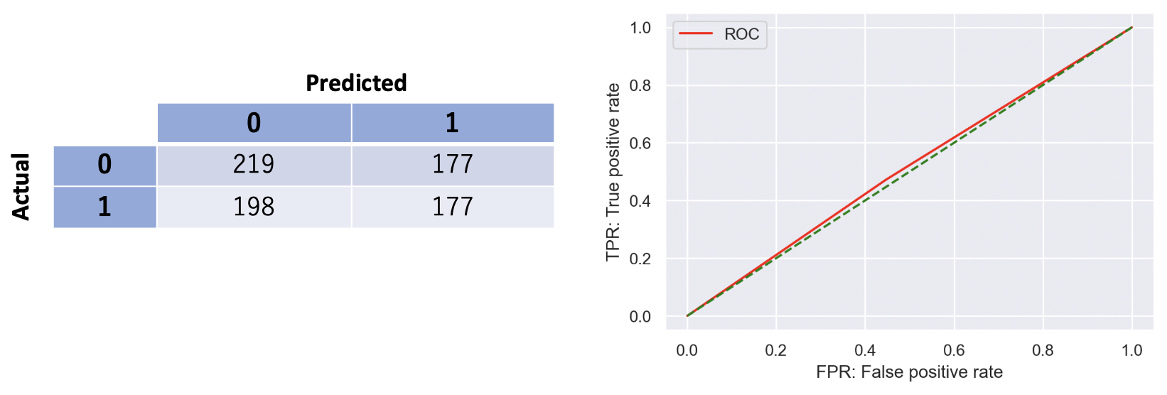

***Figure 3.1.6*** : The confusion matrix and ROC curve from boosting with three variables

### 3.1.2 Evaluating Models

The below table summarizes all models. The feature-reduced logistic regression model was the best from the accuracy and AUC.

***Table 3.1.8*** : Summary of all models

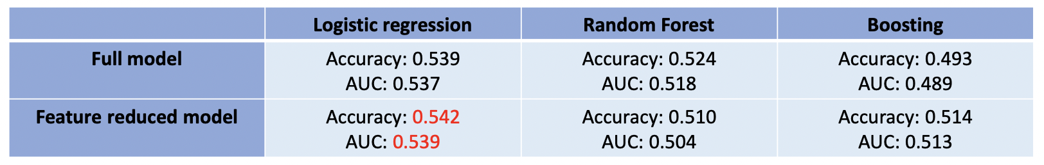

### 3.1.3 Simulation using the best model

The cumulative return was calculated using the feature-reduced logistic regression model and the test data. The starting capital was 800,000 Rupees. Cumulative returns from blind trading and strategy trading were also calculated for comparison. The strategy trading was the trading assuming that the close price would be higher/lower than the open price at NSE when the previous business day’s close price was above/below the open price at NYSE.

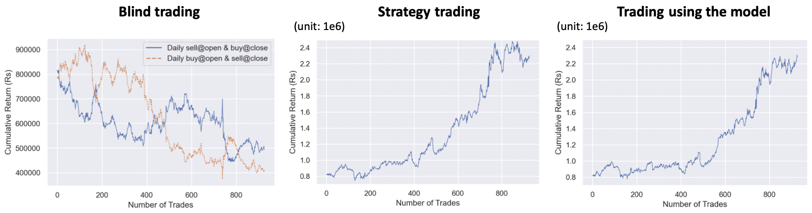

***Figure 3.1.7*** : Cumulative returns calculated by blind trading, strategy trading, and model trading

Both strategy trading and model trading resulted in making a profit, although strategy trading seems to be better. A more sophisticated model is needed to get a better result.

## 

## 3.2 Tata Motors

Although it was clear from the EDA that the trends in the NSE and NYSE were very similar, no other explanatory variables except prices were highly correlated with the response variable. However, the index values of NSE were considered as a feature for prediction.

### 3.2.1 Building Models

The data was divided into the training data (70% of the total) and the testing data (30% of the total) with random_state = 1000. The model is of the form :-

**Y**= *f* ***(******TM NSE Open, TM NSE High, TM NSE Low, TM NSE Close, TM NSE Volume, NSE index Open, NSE index Close, NSE index High, NSE index Low )***

**Logistic regression model :** The table below shows the model’s intercept and coefficients.

***Table 3.2.1*** : Intercept and coefficients of the logistic regression model with all variables

| Variable | Coefficient |
| --- | --- |
| TM NSE open | 0.023442 |
| TM NSE high | 0.134264 |
| TM NSE low | 0.873243 |
| TM NSE close | 0.149842 |
| TM NSE Volume | 0.005689 |
| NSE index open | 0.157854 |
| NSE index high | 0.179540 |
| NSE index low | 0.097347 |
| NSE index close | 0.113489 |

The figure below shows the confusion matrix calculated using the testing data and the ROC curve, respectively. The 10 fold cross validation was performed, the mean cross validation score was 0.55 and the test data accuracy and other metrics are listed below.

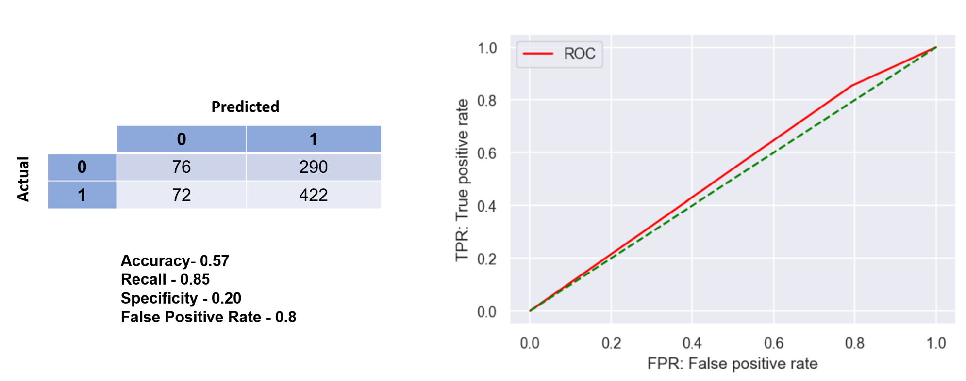

***Figure 3.2.1*** : The confusion matrix and ROC curve from the logistic regression model.

**The Random forest model.** The table below shows the hyperparameters tuned by GridSearchCV.

***Table 3.2.2*** : Hyperparameters selected by GridSearchCV

| Hyperparameter | Value |
| --- | --- |
| n_estimaters | 200 |
| max_depth | 5 |
| max_features | None |
| bootstrap | True |

The figure below shows the confusion matrix calculated using the testing data and the ROC curve, respectively. The test data accuracy and other metrics are listed below.

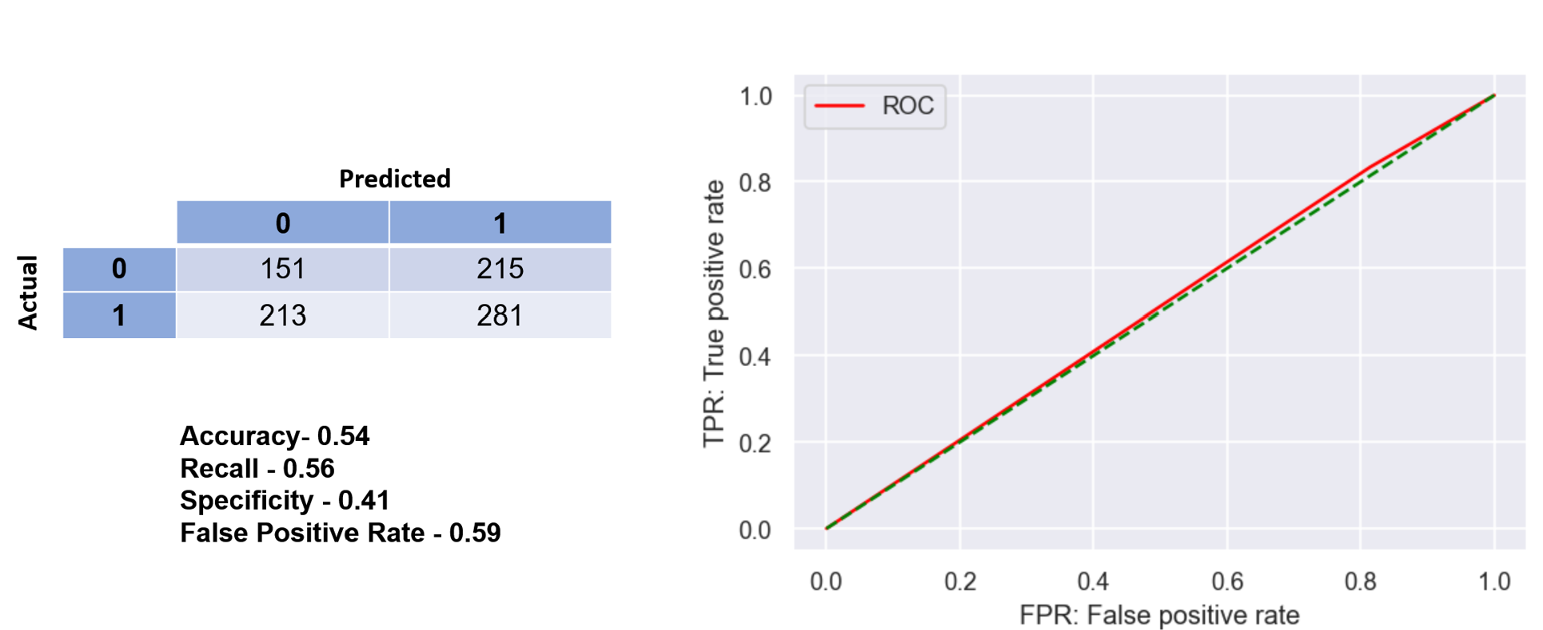

***Figure 3.2.2*** : The confusion matrix and ROC curve from the random forest

**Gradient Boosting Classifier .** The table below shows the hyperparameters tuned by GridSearchCV.

***Table 3.2.3***: Hyperparameters selected by GridSearchCV

| Hyperparameter | Value |
| --- | --- |
| n_estimaters | 100 |
| max_depth | 2 |
| learning_rate | 0.001 |
| max_features | None |

The figure below shows the confusion matrix calculated using the testing data and the ROC curve, respectively. The test data accuracy and other metrics are listed below.

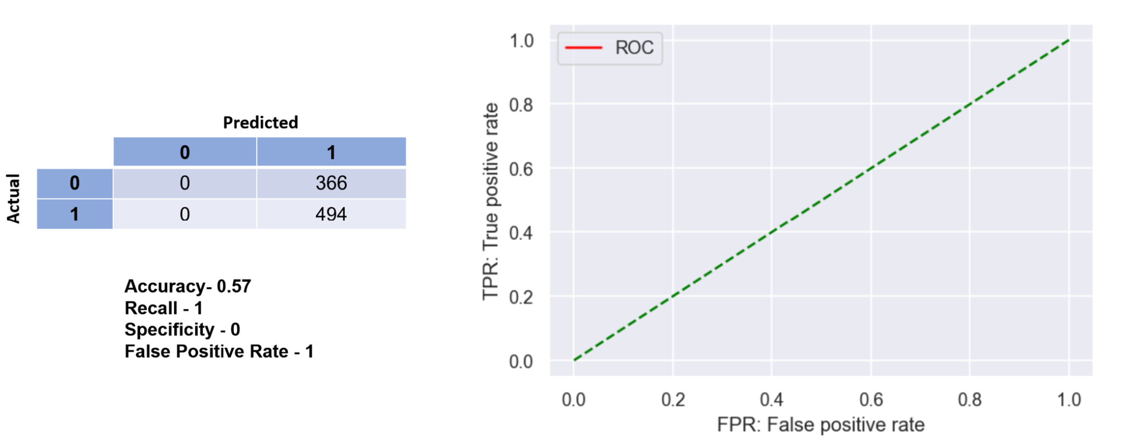

***Figure 3.2.3*** : The confusion matrix and ROC curve from the boosting

***Table 3.2.4*** : Summary of all models

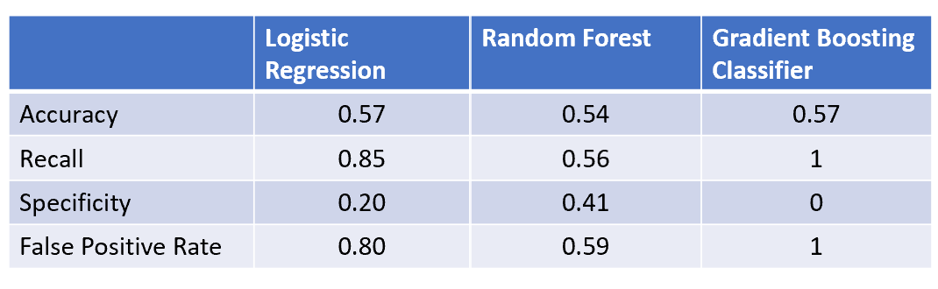

### 3.2.2 Simulation using the models

The cumulative return was calculated using all the models for the year 2022 . The starting capital was 10,000 usd. Cumulative returns charts from using strategy trading and trading using models are shown below.

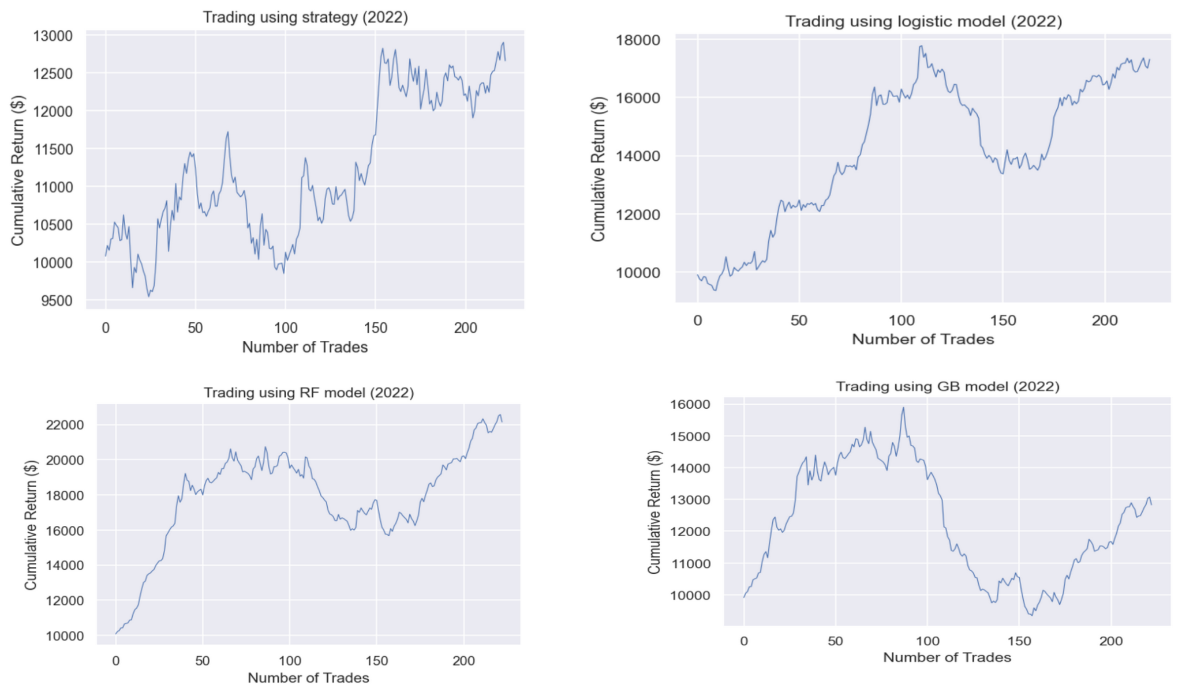

***Figure 3.2.4*** : Cumulative returns calculated by blind trading, strategy trading, and model trading

Though both strategy trading and model trading resulted in profits, Random Forest model seems to be better. But, a more sophisticated model is needed to get a reliable result.

## 

## 3.3 ICICI Bank

Again, due to the fact that, from the initial EDA and pairplots, it seemed difficult to find a relationship between the NSE indicators and the NYSE signal alone. However, the histogram of the NSE Percent Change with the signal showed a very small but exploitable discrepancy, that we will continue to use as a feature in our next models. The two metrics that will determine the best model will still be accuracy and the AUC score.

### 3.3.1 Model Summary

**Full** **logistic regression model**

In general, the logistic regression parametersThe table below shows the model’s intercept and coefficients, and below that is a figure of the confusion matrix and ROC curve. The accuracy is about 55.58%, and the AUC is about .5501. Even though the logistic regression model is the only parametric model, the coefficients of the model seem hard to explain with traditional logic. For example, the coefficients for the ICICI Bank NSE open and the NIFTY index open seem to run against each other, with one being positive and the other negative. The coefficients for the close for both the stock and index are negative, which seems to be counterintuitive, as a higher close would seem to indicate a positive trend day. The model also didn’t utilize the NSE_Percent_Change variable much.

***Table 3.3.1*** : Intercept and coefficients of the full logistic regression model

| Variable | Coefficient |
| --- | --- |
| Intercept | -0.05054249 |
| Open | 3.98105570 |
| Close | -8.88036916 |
| High | 2.47193552 |
| Low | 2.52468018 |
| Volume | .004622285 |
| OpenNifty | -3.58733571 |
| HighNifty | -.373059744 |
| LowNifty | 5.87272652 |
| CloseNifty | -2.05647985 |
| NSEDiffHL | .026241930 |
| NSE_Percent_Change | .413271309 |

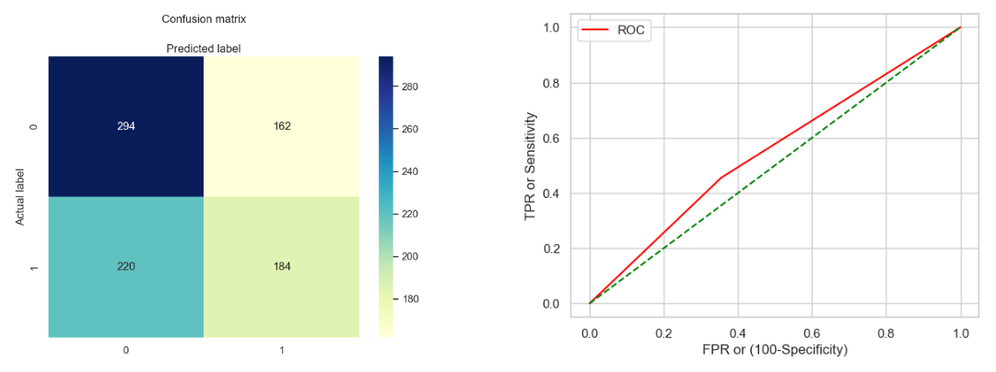

***Figure 3.3.1*** : The confusion matrix and ROC curve from the full logistic regression model

**Random Forest Classification**

The table below shows the model’s hyperparameters, and below that is a figure of the confusion matrix and ROC curve. The accuracy is about 56.98%, and the AUC is about .5652. Out of all of the features, the two features of highest importance are NSE_Percent_Change with .543, and Volume with .109 importance respectively. Unlike the logistic regression, NSE_Percent_Change is the dominant feature in this model, and the Random Forest Classification model had both the highest accuracy and AUC out of the three models, and will be used in the simulation.

***Table 3.3.2*** : Intercept and coefficients of the Random Forest Classification model

| Hyperparameter | Value |
| --- | --- |
| n_estimaters | 500 |
| max_depth | 2 |
| bootstrap | True |
| max_features | None |

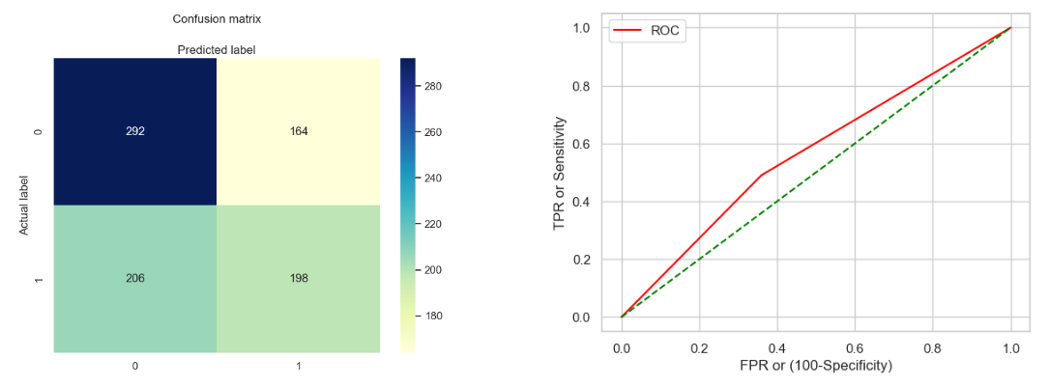

***Figure 3.3.2*** : The confusion matrix and ROC curve from the Random Forest Classification

**Gradient Boosted Trees**

The table below shows the model’s hyperparameters, and below that is a figure of the confusion matrix and ROC curve. The accuracy is about 54.2%, and the AUC is about .5345. Like the random forest classification model, the two features of highest importance are NSE_Percent_change with .253, and Volume with .143 importance respectively.

***Table 3.3.3*** : Intercept and coefficients of the Gradient Boosted Trees model

| Hyperparameter | Value |
| --- | --- |
| n_estimaters | 88 |
| max_depth | 2 |
| learning_rate | 0.01 |
| max_features | sqrt |

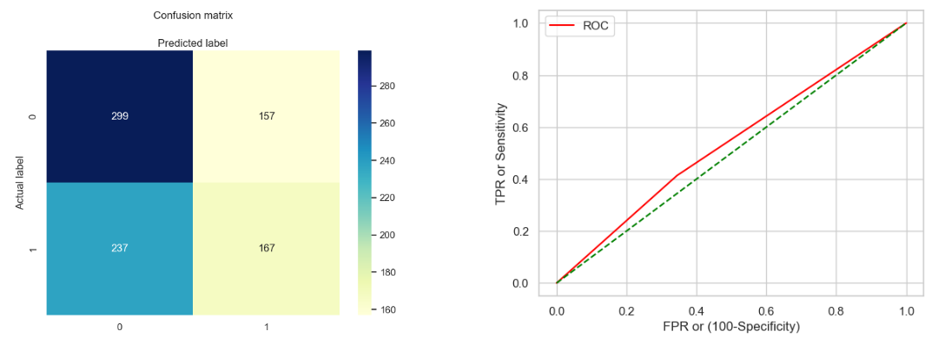

***Figure 3.3.3*** : The confusion matrix and ROC curve from the Gradient Boosted Trees model

### 

### 3.3.2 Simulation using the best model

With the Random Forest Classification model, a simulation was run to calculate the potential earnings/loss of three strategies: Blind trading, NSE to NYSE Signal trading, and Model trading (using the Random Forest model). For the blind trading, a randomly generated binary would pick either to buy or not to buy at the start of every day. The NSE to NYSE Signal trading only utilized the direction of the NSE to make a prediction. The starting capital was 10,000 dollars, and a cumulative return was calculated on the NYSE, factoring in broker expenses and whole stock prices.

As expected, the blind trading strategy performed the worst out of the three strategies. Both the NSE to NYSE Signal trading and the model followed a very similar trend, due to the importance of the NSE_Percent_Change feature in the model. Still, the model trading showed a marked increase of about 10000 dollars over the strategy trading over the 10 year period. In comparison to someone who bought and held the stock, they would’ve profited 362% of their initial investment over the 10 years. However, both the NSE to NYSE Signal and the model trading strategies would profit 2400% to 2600% in the same time period.

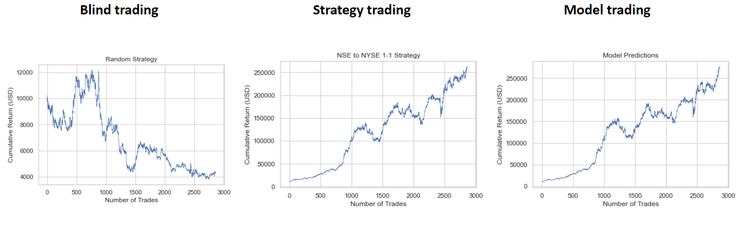

***Figure 3.3.4*** : Simulations of three different Trading Strategies

# 4. Future Research and Models

Due to the fact that we sourced our data for free from Yahoo! Finance, the quality of our dataset could be improved for future explorations. For example, our data only summarized the daily trends, rather than the real-time trends in the day, and the only features available were the open, high, low, and close prices of that day, as well as the total volume traded during that day. If data with higher temporal resolution (e.g., data every 5 minutes) was available, it could be possible to produce a better model with more data points.

Likewise, we could add more features that could give insight into our response variable that the other indicators could not. As one example, stock prices can also depend on human sentiment, like the general views on the stock market or the specific company as a whole, something that we did not have access to in our dataset. Therefore, it would be possible to construct a stronger model if the factors influencing human sentiment could be quantified, converted into data, and incorporated into our models as possible features. Another example would be to incorporate more interaction terms in our models. For another example, while volume and percent change can both be strong predictors in a model, it would make more logical sense in the real world to include a volume:percent_change interaction term, as that would show whether an event caused a great overall positive surge or negative surge for the day.

Lastly there is the possibility of using alternative models to predict the response. We could add models that sentiment traders already use to further increase the accuracy of our models and help supplement our original strategy. Likewise, we could use different modeling techniques, like possible time series models (Autoregressive Integrated Moving Average or Recurrent Neural Networks models) in our study to better track the overall trend of a stock.